3rd July 2016

Dear Members,
Ref:-Associazione i Nonni (Grandparents) need your EMAIL ADDRESS

Some of you have already filled in new membership forms to update your particulars’ however it is very important to fill in your email address if by an chance you have no email address one of your children or grandchildren may have, unfortunately any future correspondence will be by email we apologies for this but we must change please also visit us on
www.associazioneinonni.com.au

Joe Commisso
President
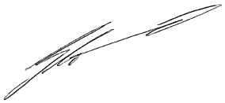
Ambassador NSW Grandparents Day

Suite 208, 29-31 Lexington Dr, Bella Vista, NSW 2153 Australia
Ph: 8882 8000 Fax: 8882 8080 Email: info@associazioneinonni.com.au Web: www.associazioneinonni.com.au

