4th May 2016
To whom it may concern,
Subject: Request of a donation to: - Associazione i Nonni’s Literary Competition
My name is Joe Commisso and I’m writing as President and Ambassador of the NSW Associazione i Nonni, to announce the Literary Competition 2016: “A journey back to origins”.
The Association I’m proud to represent, values the importance of the relationship between grandparents and grandchildren.
This competition aims to encourage a stronger communication between grandchildren and their grandparents. The participants will be asked to write an essay in English in which they recount the life story of their grandparents before leaving their country of origin and their experience as New Australians. The best essays will be collected in an anthology by the title: “A journey back to origins”.
I’m attaching the letter with terms and conditions of the literary competition. As you will see, we are offering very good prizes to the winners. We are also organizing a big gala night for the presentation of the awards.
I’m kindly asking you if your company would collaborate with Associazione I Nonni on this endeavour and make a donation to help finance the prizes and cover the printing cost of the anthology. Needless to say that your contribution will be properly acknowledged on the book, on all the flyers and vouchers we are going to print to run the competition, as well as on our website and on the articles to La Fiamma.
The Associazione i Nonni’s literary competition intends to provide a great opportunity to reaffirm the irreplaceable role grandparents have in their families and in the wider community. We would really appreciate your collaboration in achieving this objective.
Please find attached the letter with terms and conditions of the competition.
I sincerely hope that this initiative will find your interest.
Very Best Regards
Joe Commisso Antonio Bamonte
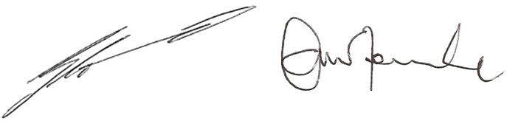
President Vice President

Ambassador NSW Grandparents Day Comm. Antonio Bamonte, OAM
Suite 208, 29-31 Lexington Dr, Bella Vista, NSW 2153 Australia
Ph: 8882 8000 Fax: 8882 8080 Email: info@associazioneinonni.com.au Web: www.associazioneinonni.com.au

