The
Associazione i Nonni
announces
The
LITERARY COMPETITION 2016: “A journey back to origins”

The Nonni Association Literary Competition “A Journey back to origins” aims primarily at opening a channel of communication between grandparents and grandchildren. It’s therefore open to all grandchildren of Italian origin from 10 to 25 years of age.
The entrants are invited to submit an essay or a short novel, in which they briefly recount their grandparent’s life before and after immigrating to Australia. They will be provided with a questionnaire, containing questions to their grandparents. The participants are encouraged to be creative and to express their personality.
Terms and Conditions:
1. Texts shall be submitted in English.
2. Texts shall be unpublished, typed for a maximum 2,000 words or less, failing which they will be excluded from assessment. They shall be typed double-spaced with a font size not smaller than 12.
3. Each participant can present only one work.
4. Entries shall be sent in unidentified 4 copies, together with a sealed envelope containing personal data of the participants,
to: PO. Box 116 Haberfield 2045. In order to maintain full privacy and not to be identified, the participants will be asked to refer to their grandparents only with their first names (for example: Nonno Antonio o Nonna Maria).
5. Closing date for ALL entries is Friday 26th August 2016 at 5pm.
6. The judging panel will be selected by the Associazione i Nonni’s Committee.
7. The award of prizes will be decided by a majority vote of the judging panel. The decisions of the judging panel cannot be disputed.
8. Other entries, considered of significant value, may be recommended by the judging panel for publication, together with the winning entries, in the book which will follow the competition. The Associazione i Nonni is in fact willing to publish a book which will collect the most interesting essays.
The prizes will be as follows:

CATEGORY 1: for participants from 10 to 14 years of age
First Prize: 2 economy return air tickets to Italy+ 1 week stay in Rome
2nd Prize: $ 1.000.00
3rd Prize: $ 500.00

CATEGORY 2: for participants from 15 to 19 years of age
First Prize: 2 economy return air tickets to Italy+ 1 week stay in Rome
2nd Prize: $ 1.000.00
3rd Prize: $ 500.00

CATEGORY 3: for participants from 20 to 25 years of age
First Prize: 2 economy return air tickets to Italy + 1 week stay in Rome
2nd Prize: $ 1.000.00
3rd Prize: $ 500.00
The winners will receive written communication prior to the awarding ceremony which will take place in October 2016. Winners shall guarantee their presence to the awarding ceremony, which will be advised.
The Associazione i Nonni extends special thanks to all of you for your precious cooperation, to SBS, Italian radio and the Italian-Australian newspaper La Fiamma for their media coverage of the competition, to the Sponsors and, last but not least, to the grandchildren who will put their time and efforts.

Buon lavoro and the best of luck

Joe Commisso Antonio Bamonte
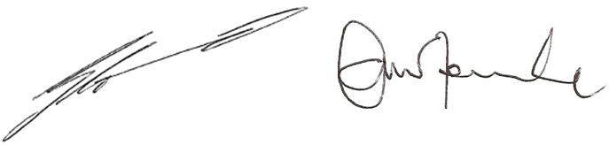
President Vice President

Ambassador NSW Grandparents Day Comm. Antonio Bamonte, OAM
Suite 208, 29-31 Lexington Dr, Bella Vista, NSW 2153 Australia
Ph: 8882 8000 Fax: 8882 8080 Email: info@associazioneinonni.com.au Web: www.associazioneinonni.com.au

